Kindergarten Lesson Plans: Jan. 9-13, 2023 Module 5- Week 1 Theme: Snow and winter
Read-aloud: Jabari Jumps Big Book: All by Myself Genre: Fiction
Spelling words: Assessments: Spelling test
 | Reading and Vocabulary  *Whole Group | Foundational Skills  * Intro whole/review small group | Writing Workshop  *Whole group | Small Group Instruction  (Teacher group) | Centers
Monday-  Lesson 1  Heggerty  Week 17 | Introduce new topic and voc. words: practice, proud, success p.T26  Read Jabari Jumps | Blend phonemes into words p.T30  Identify and pronounce short/long u p.T31-33 | Narrative writing p.T34-35 | Blend spoken phonemes p.T36  Short/long u words  Sight words  Letters/sounds  Leveled Readers | Assistant – Handwriting/HFW  Independent-  Trace a snowman and add details. Write a sentence about snowman.  Math -
Tuesday-  Lesson 2  Heggerty  Week 17 | Vocabulary words-  Important, scared, surprise  p.T38  Read Jabari Jumps  Anchor Chart: Character Clues | Blend phonemes into words p.T40  Letter /sounds: /u/ p.T41  Read decodable text  Nuts, Not Rugs!  Words to know: up, but, not, want, look | Narrative writing-identify beginning, middle and end p.T44-45 | Identify initial, medial, and final sounds in one-syllable words  Onset and rimes  Listen for short u and long u in words  Sight words  Letters/sounds  Leveled Readers | Assistant – Handwriting/HFW  Independent-  Spelling word snowmen-TSW build spelling words on snowmen and then write/copy a sentence with 2 of the spelling words.  Math -
Wednesday-  Lesson 3  Heggerty  Week 17 | Character feelings—discuss how the character’s feelings change p.T48-49  Read Jabari Jumps  Read All By Myself  Identify character, setting, and events | Produce rhymes p.T52  Review short u  Alphabet songs | Practice writing complete sentences and using signal words to show sequence in a story.  Anchor Chart: Story Writing 1 | Identify initial sounds, medial and final sounds  Word work- sort words with middle sound /u/  Identify letters/ sounds  Sight words  Leveled readers | Assistant – Handwriting/HFW  Independent-  Sort pictures with short and long /u/  Math -
Thursday-  Lesson 4  Heggerty  Week 17 | Review All By Myself  Use picture clues to identify character feelings. P.T60 | Produce rhymes p.T62  Build/spell words with short u p.T63  Read decodable text  Big Bugs  Alphabet songs | Introduce pronouns I and me p.T66  Write complete sentences with I and me. | Review identifying initial sounds, medial, and final sounds  Produce rhymes  Identify letters/sounds  Sight words  Leveled readers | Assistant – Handwriting/HFW  Independent-  TSW make a snow globe and complete the writing prompt “If I lived in a snow globe I would…”  Math -
Friday-  Lesson 5  Heggerty  Week 17 | Respond to text p.T70-71  Review voc.: important, scared, and surprise | Review blending and rhyming p.T72  Spell words with short u p.T73 | Use pronouns I and me in spoken sentences and written sentences. P.T76 | Produce rhymes  Review words with medial short /u/  Letters/sounds  Sight words | Assistant – Handwriting/HFW  Independent-  Snowy Sounds WS—final sounds practice  Math -
ELA Standards:

- RL.K.3 With prompting and support, identify characters, settings, and major events in a story.
- RF.K.3a Demonstrate basic knowledge of one-to-one letter-sound correspondences by producing the primary sound or many of the most frequent sounds for each consonant.
- RL.K.10 Actively engage in group reading activities with purpose and understanding.
- L.P.2a Write first name, capitalizing the first letter.
- L.K.2c Write a letter or letters for most consonant and short-vowel sounds.
- RF.K.1 Demonstrate understanding of the organization and basic features of print.
- RF.K.2 Demonstrate understanding of spoken words, syllables, and sounds (phonemes).
- RF.K.2a Recognize and produce rhyming words.
- RF.K.2b Count, pronounce, blend, and segment syllables in spoken words.
- RF.K.2d Isolate and pronounce the initial, medial vowel, and final sounds (phonemes) in three-phoneme (consonant-vowel-consonant, or CVC) words.
- RF.K.3c Read common high-frequency words by sight.
- W.K.3 Use a combination of drawing, dictating, and writing to narrate a single event or several loosely linked events, tell about the events in the order in which they occurred, and provide a reaction to what happened
- W.K.5 With guidance and support from adults, respond to questions and suggestions from peers and add details to strengthen writing as needed.
- L.K.1b Use frequently occurring nouns and verbs.

Math Skill Objectives
- K.CC.3 Write numbers from 0 to 20. Represent a number of objects with a written numeral 0-20 (with 0 representing a count of no objects).
- K. CC.4a When counting objects, say the number names in the standard order, pairing each object with one and only one number name and each number name with one and only one object.
    - b. Understand that that last number name said tells the number of objects counted. The number of objects is the same regardless of their arrangement or the order in which they were counted.
- K. CC 6 Identify whether the number of objects in one group is greater than, less than, or equal to the number of objects in another group, e.g., by using matching and counting strategies.
- K. CC 7 Compare two numbers between 1 and 20 presented written numerals.
- K. OA 3 Decompose numbers less than or equal to 10 into pairs in more than one way, e.g., by using objects or drawings, and record each decomposition by a drawing or equation (e.g., 5 = 2 + 3 and 5 = 4 + 1).
- K. OA 4 For any number from 1 to 9, find the number that makes 10 when added to the given number.
- K.OA 1 Represent addition and subtraction, in which all parts and whole of the problem are within 10, with objects, fingers, mental images, drawings2 , sounds (e.g., claps), acting out situations, verbal explanations, expressions, or equation.

Math Lessons | Math Activities
Monday-Lesson 18 Add within 10  Tuesday – Lesson 18 Add Within 10  Wednesday – Lesson 18  Thursday – Lesson 18  Friday- review Lesson 18  TSW draw buttons on two dicut snowmen and write an addition sentence.  Trace a big snowman and draw buttons with two colors. Then, write an addition sentence.  Draw snow balls to represent addition problems and solve. | TSW practice writing numbers 0-20 on handwriting paper.  K.CC.3 Write numbers from 0 to 20. Represent a number of objects with a written numeral 0-20 (with 0 representing a count of no objects).  TSW use cotton balls to illustrate and write addition problems on a mitten.  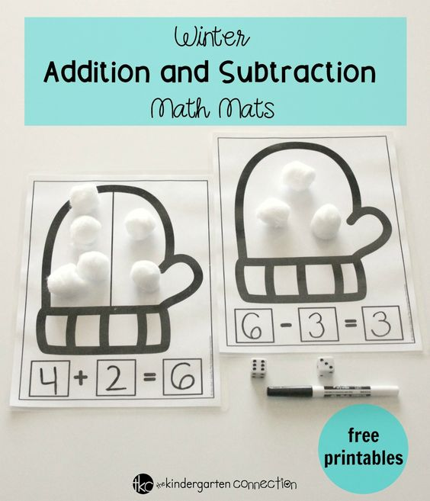  Use cubes to represent addition problems. Solve and write answers.  Use marshmallows on a mug to show addition problems.

Science: P.K.5A Students will demonstrate an understanding of the solid and liquid states of matter.
Health: Competency 7: Demonstrate the ability to practice health-enhancing behaviors and avoid or reduce health risks.

Monday | Tuesday | Wednesday | Thursday
Science  Discuss the states of matter in regards to snow. | Health  Define germs and discuss ways of protection from illness (flu season). | Science  Observe how water changes from liquid to solid, and how it changes shapes. | Health  Demonstrate proper way to cough and sneeze away from people.
Science  https://www.youtube.com/watch?v=7AeiwLhFuFQ | Health  https://www.youtube.com/watch?v=NoxdS4eXy18 | Science  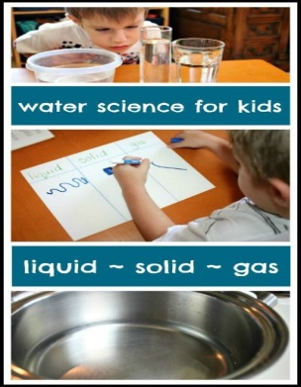 | Health  https://www.youtube.com/watch?v=DG4n0r8-UPA

